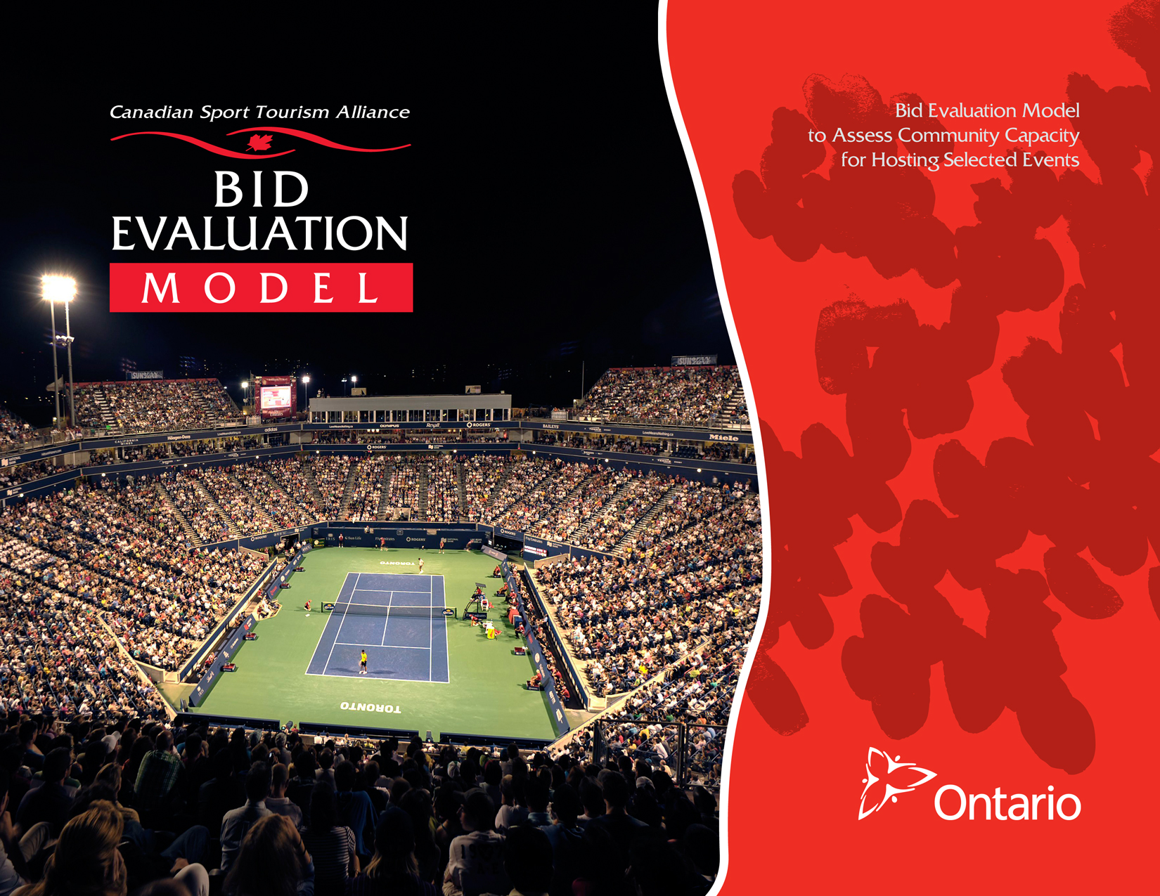

# Bid Evaluation Model

# to Assess Community Capacity

# for Hosting Selected Events

# Acknowledgements

The Canadian Sport Tourism Alliance (CSTA) gratefully acknowledges the contribution of the following agencies and individuals in the creation of this template:

* Funding for the project was provided in part by the Government of Ontario.
* The author of the Bid Evaluation Model is Lynn Morrow, the principal of Lynn Morrow Consulting in Toronto, who can be reached at [lynnmorrow@sympatico.ca](mailto:lynnmorrow@sympatico.ca)
* The template is part of the CSTA’s Transfer of Knowledge program under the leadership of Eric Savard, Program Director and Rick Traer, Chief Executive Officer.

[**www.canadiansporttourism.com**](http://www.canadiansporttourism.com)

© Copyright 2012

Canadian Sport Tourism Alliance

All rights reserved.

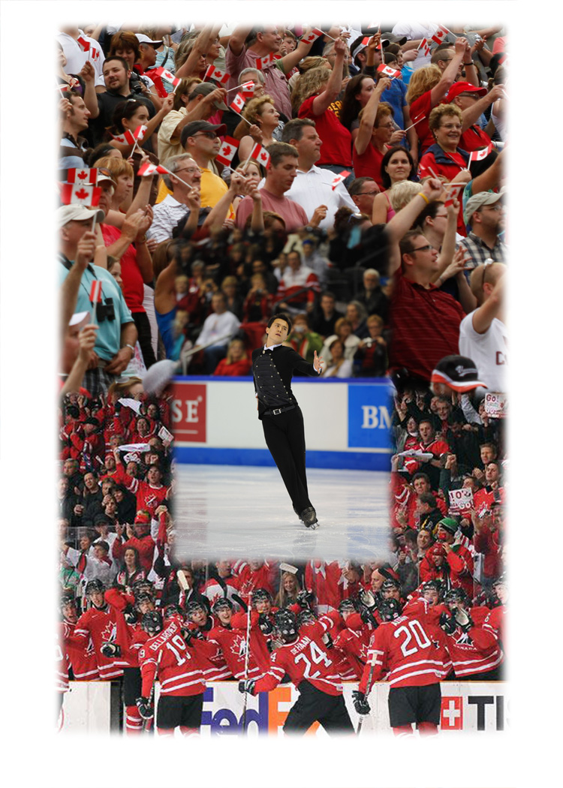

# Table of Contents

**Table Of Contents 3**

**Introduction 4**

**How To Use The BEM 4**

**1. Infrastructure Assets 5**

1.1 Sport Facilities/Venues 5

1.2 Accommodation 5

1.3 Food & Beverage Services 6

1.4 Transportation 6

1.5 Media Broadcast Capacity 6

1.6 Medical Services 6

**2. Community Support 7**

2.1 Sport Clubs 7

2.2 Commitment 7

2.3 Critical Mass 7

2.4 Business 7

**3. Public Sector Support 8**

3.1 Government Support 8

3.2 Working Capital 8

**4. Management & Event Expertise 9**

4.1 Leadership 9

4.2 Experience 9

**5. Financial Considerations 10**

5.1 Size 10

5.2 Sport Popularity 10

5.3 Event Reputation 10

5.4 Economic Value 11

5.5 Post-Event Expenses 11

**6. Competitive Context 12**

6.1 Bid Process 12

6.2 Previous Hosts 12

6.3 Competition 12

**7. Sustainability 13**

7.1 Suitability 13

7.2 Marketability 13

7.3 Legacy 14



# Introduction

The Bid Evaluation Model (BEM) is intended to function as a decision support tool, assisting organizations/municipalities who are considering a bid to host a particular sport tourism event to determine whether to proceed with the bid proposal relative to a variety of important elements. A precursor to preparing a business case or feasibility study, the goal of the BEM is to provide a relatively quick assessment of the fit between the community’s assets and the event rights holder’s requirements.

The tool can be applied to a variety of sport event hosting opportunities at the local, provincial, national and international level.

At a high level, the BEM will help to provide a consistent, quantified assessment of the relative suitability of a particular event for a specific community at a given point in time. Premised on the congruity between a particular event rights holder’s requirements and the potential bidder’s sport, tourism and community infrastructure—facilities, resources and capacities—the model highlights associated resources and deficiencies, which may contribute to potential risks and rewards. The BEM is built around six modules:

1. Infrastructure assets

2. Community Support

3. Public Sector Support

4. Management and Event Expertise

5. Financial Considerations

6. Competitive Context

7. Sustainability

**The benefits of using the BEM are twofold:**

* Provides the community/bid group with an early indication of the community’s event readiness and deficit areas needing attention. The user will also have a sense of the anticipated net benefits of hosting that would accrue to the organization/community and to the broader region or province.
* Over the long term, organizations that ensure they have a competitive chance to win a bid for a particular event before approaching government or corporate sponsors for support will gain credibility and are more likely to gain support than those who do not.

# How to Use the BEM

In tandem with completing the BEM, an Infrastructure Inventory/Event Requirements Matrix can be an invaluable tool in determining a community’s ability to satisfy a particular event rights holder’s fundamental requirements. Adding dates, details and metrics to facility requirements (e.g., international, national, provincial, regional level athletic standards, seating capacity, number, quality and price point of accommodation, etc.), quickly highlights gaps. A determination then needs to be made as to how those gaps can be filled, at what cost and in what timeframe.

Working through the BEM, a number of decision points are presented offering a Go/No Go determination. Within each section of each module a series of questions are asked and an affirmative response is required to move forward. If the response is “No” above the divider line the respondent is pointed to the question below the divider line. If the response continues to be “No” the recommendation is to not pursue bidding on the event, at least at this time. A “No” response is in effect a red flag asking the respondent to reconsider the bid or consider strategies that may work to address the requirement.

|  |  |  |  |  |  |
| --- | --- | --- | --- | --- | --- |
| Event Name:  Date:  Rights Holder: | | | | | |
| **1. Infrastructure Assets** | | | | | |
| Understanding and fulfilling event rights holders’ requirements for hosting sport tourism events is essential to winning bids to host a particular event. This begins with an assessment of the infrastructure required by the event rights’ holder as compared to the inventory of community assets available in the potential host community.  The successful host community must demonstrate the availability, quality and appropriate standard of infrastructure—sport, tourism and community. This includes athletes, officials and spectator accommodation, food service, venues, sport facilities, transportation, media/broadcasting networks and signals, technical production requirements and access to sport medicine. Should there be any gaps in the required infrastructure, the successful host community must demonstrate its capacity. | | | | | |
| *The Go/No Go Decision—an affirmative response to the following questions must be indicated in each category; if the response is “No” above the divider, it must be “Yes” below to consider pursuing a bid to host the event in question. If the response it “No” both above and below the divider, do not pursue bidding on the event, at least at this time.* | | *Yes* | | *No* | |
| **1.1 Sport Facilities/ Venues** | Does your community have the sport facilities and venues required by the Event Rights Holder? Consider availability, standards, accessibility, seating capacity, technological features, security, marketing restrictions, assembly requirements, etc. |  | | Go to B | |
| B | If any facilities/venues are missing   * Are they planned and funded and can you guarantee they will be available in advance of the event? * Are there alternative ways to provide the requisite facility(ies)? [e.g., partner with neighbouring community, etc.] |  | |  | |
| **1.2 Accommodation** | *Calculate the number, quality and price point of rooms required to accommodate the anticipated athletes, officials and spectators.* | |  |  | |
|  | Do sufficient rooms exist to accommodate the anticipated visitors? | |  | | Go to B |
|  | Will sufficient rooms be available (vacant) during the event period? [e.g., will providers reserve/guarantee a sufficient block of rooms?] | |  | | Go to B |
|  | Is a range of accommodation available that encompasses various types, quality levels and prices? | |  | | Go to B |
| B | If any of the above questions receive a negative response, are there opportunities to expand the accommodation base to fill the gaps? [e.g., temporary housing, school dormitories, shuttle services to neighbouring communities, billeting, etc.] | |  | |  |

|  |  |  |  |
| --- | --- | --- | --- |
| **1.3 Food & Beverage Services** | Is there a range of food options available at or near the accommodations? |  | Go to B |
|  | Are banquet/catering facilities with sufficient seating and serving capacity available at affordable rates? |  | Go to B |
| B | If no, are there opportunities to expand the food and beverage services? |  |  |
|  | If no, are there opportunities to expand the banquet/catering facilities? |  |  |
| **1.4 Transportation** | Does your community have good access by air, road and rail? Consider availability of airport and rail station, distance to and from airport/rail station and accommodations, level of congestion. |  | Go to B |
|  | Is the cost of travel to your community from various points of origin reasonable? |  | Go to B |
|  | Does your community have a good public transportation system? |  | Go to B |
|  | Can distances among venues, facilities and accommodation be traversed with ease? |  | Go to B |
| B | If no, are there opportunities to enhance access to and within the community? For example, can you readily organize shuttle service to and from facilities, venues and accommodation as required? |  |  |
| **1.5 Media Broadcast Capacity** | Is there a host broadcaster/network available? |  | Go to B |
|  | Is there a reliable international signal in your community? |  | Go to B |
|  | Can you meet specific technical production requirements? Consider availability of media centre, accreditation services, etc. |  | Go to B |
| B | If no, are there alternative ways to address the gaps in media requirements? |  |  |
| **1.6 Medical Services** | Is there ready access to sport medicine? |  | Go to B |
| B | If no, are there opportunities to ensure sport medicine is accessible during the event? |  |  |

|  |  |  |  |
| --- | --- | --- | --- |
| **2. Community Support** | | | |
| The local community and volunteers are critical to the success of any sport event and an important resource that must be effectively utilized if the event is to run smoothly. | | | |
| *The Go/No Go Decision—an affirmative response to the following questions must be indicated in each category; if the response is “No” above the divider, it must be “Yes” below to consider pursuing a bid to host the event in question. If the response it “No” both above and below the divider, do not pursue bidding on the event, at least at this time.* | | *Yes* | *No* |
| **2.1 Sport Clubs** | Are the relevant sport federations/associations active in your community and committed to the bid? |  | Go to B |
| B | If no, do you have strategies to build alliances with local sport clubs? |  |  |
| **2.2 Commitment** | Does the bid/event have broad-based community support? |  | Go to B |
| B | If no, do you have strategies to gain community support? |  |  |
| **2.3 Critical Mass** | Will you have sufficient numbers of committed volunteers? |  | Go to B |
|  | If needed, do you have the volunteer capacity to provide services in a range of languages? |  | Go to B |
|  | Do you have the capacity to assemble, train and manage sufficient numbers of volunteers? |  | Go to B |
| B | If no, do you have strategies to assemble, train and manage sufficient numbers of volunteers? |  |  |
| **2.4 Business** | Does your business community support the event and interested in contributing to its success? |  | Go to B |
| B | If no, do you have strategies to engage the business community? |  |  |

|  |  |  |  |
| --- | --- | --- | --- |
| 3. Public Sector Support | | | |
| Public sector—political and administrative—support is essential to winning bids and successfully hosting events. Networks, partnerships and influence need to be cultivated well in advance of any bid to host a sport tourism event. The breadth and scope of public sector engagement will vary depending on the scale and prestige of the event. | | | |
| *The Go/No Go Decision—an affirmative response to the following questions must be indicated in each category; if the response is “No” above the divider, it must be “Yes” below to consider pursuing a bid to host the event in question. If the response it “No” both above and below the divider, do not pursue bidding on the event, at least at this time.* | | *Yes* | *No* |
| **3.1 Government Support** | Do you have support for hosting the event from relevant federal, provincial and municipal leaders, both political and bureaucratic? [Consider planning, development and infrastructure approvals, access to programs and funding, debt guarantees, political, economic and trade relationships, letters of support, etc.] |  | Go to B |
| B | If no, do you have strategies to gain support of federal, provincial and municipal leaders in a timely manner? |  |  |
| **3.2 Working Capital** | Do you have sufficient working capital to fund the bid process and pay prescribed event rights fees? |  | Go to B |
| B | If no, is a strategy in place to obtain sufficient working capital to provide the resources required to prepare a compelling bid? |  |  |

|  |  |  |  |  |
| --- | --- | --- | --- | --- |
| 4. Management & Event Expertise | | | | |
| Event bid teams must comprise membership with   * An understanding of federal and provincial hosting policies and major sport tourism events rights holders’ criteria; * Professional skills to prepare business plans, assess the impact of hosting sport events, proficiency in human resource (volunteer recruitment and retention) and event management; * An appreciation of the need to adopt policies and practices consistent with a green agenda; * Strong networks in both the sport and tourism sectors; * Effective linkages to community leaders; * Credibility in the relevant sport and competitive environment. | | | | |
| *The Go/No Go Decision—an affirmative response to the following questions must be indicated in each category; if the response is “No” above the divider, it must be “Yes” below to consider pursuing a bid to host the event in question. If the response it “No” both above and below the divider, do not pursue bidding on the event, at least at this time.* | | | *Yes* | *No* |
| **4.1 Leadership** | Do you have tourism, sport and business expertise and municipal experience on your core team? If considering a bid for a national or international event, do members of the core team also have national or international credibility? |  | | Go to B |
|  | Does the bid group have competencies in business plan development, financial management, human resources and event management, as well as an appreciation for environmental requirements? |  | | Go to B |
|  | Do members of your bid group have linkages with corporate sponsors? |  | | Go to B |
| B | If no, can you recruit members to the bid group with the relevant skills, experience and networks? |  | |  |
| **4.2** **Experience** | Has your community/organization previously bid to host a sport tourism event? |  | | Go to B |
|  | Has your community/organization previously hosted an event of a similar scale and scope? Were the outcomes positive? |  | | Go to B |
|  | Has your community/organization experience in running successful sport events at a similar level of competition? |  | | Go to B |
| B | If no, do you have a strategy to gain knowledge from past bidding and hosting experiences? |  | |  |

|  |  |  |  |  |  |  |
| --- | --- | --- | --- | --- | --- | --- |
| **5. Financial Considerations** | | | | | | |
| Hosting major sport events offers communities the potential to capture significant benefits across a broad range of objectives, as events have the potential to act as a catalyst for generating substantial economic and social wealth. Economic benefits may include increased levels of tourism, job creation, enhanced public infrastructure and increased tax revenue. Social benefits, such as unique work experiences, training and youth participation, volunteer promotion and an increased emphasis on fitness and health may be realized. Major sport events may also raise a community’s profile and contribute to place making and regeneration.  However, bidding and hosting sport tourism events requires significant investment and everyone involved—bid organization/community, government, corporate sponsors and rights holders—wants to maximize the return on investment, be it in the form of revenue or broader economic impacts. Hence, demonstrating financial return is critical to any bid as is limiting financial risk.  While a community may benefit from hosting a particular regional or provincial event, the economic focus of sport tourism should include the creation of wealth, rather than simply relocating economic activity within a region. A sport tourism event should therefore have the potential to reap a net economic benefit that is broader than a single community or region. | | | | | | |
| *The Go/No Go Decision—an affirmative response to the following questions must be indicated in each category; if the response is “No” above the divider, it must be “Yes” below to consider pursuing a bid to host the event in question. If the response it “No” both above and below the divider, do not pursue bidding on the event, at least at this time.* | | | *Yes* | | *No* | |
| **5.1 Size** | Is the size of the event sufficient to generate out of region/province/country visitors and T.V. viewership? | | |  | | Go to B |
| B | If no, are there sufficient community benefits to hosting the event to offset out of region attendance/viewership? | | |  | |  |
| **5.2 Sport Popularity** | | Will the event attract significant public interest? Consider sport popularity in Canada, event prestige, level of Canadian performance internationally in relevant sport(s) [e.g., highly competitive/strong spectator sports bring a substantial number of participants, officials, staff and captive/loyal fans] | |  | | Go to B |
| B | | If no, is a strategy in place to gain substantial public interest in the event? | |  | |  |
| **5.3 Event Reputation** | | Is the marketability of the event sufficient to attract corporate sponsors and media coverage? Consider event’s prestige, rights holder’s reputation, size and scale of event, positive brand attributes of the sport, historical track record of corporate support, Canadian performance internationally, sport governing body’s reputation and delivery system, audience demographics (e.g., events that appeal to younger and more affluent markets appeal to corporate sponsors), anticipated viewership, etc. | |  | | Go to B |
| B | | If no, is a strategy in place to enhance the event’s marketability? Do you have reasonable assurance of corporate sponsors and/or media outlets interest in and support of the event? | |  | |  |
| **5.4 Economic Value** | | Will the event provide economic benefits prior to and during the event, as calculated by STEAM? [Economic benefit could include increased GDP, increased tourism, job creation, enhanced infrastructure and increased tax revenue, etc.] | |  | | Go to B |

|  |  |  |  |
| --- | --- | --- | --- |
|  | Will the event provide economic benefits following the event, as calculated by STEAM PRO? [Economic benefit could include increased tourism, job creation, enhanced infrastructure and increased tax revenue, etc.] |  | Go to B |
| B | If no, are there sufficient value-added benefits (e.g., experience, reputation, positioning for next bid, etc.) to be derived from hosting the event to off-set its low economic value? |  |  |
| **5.5 Post-event Expenses** | Is the municipal tax base sufficient to carry the ongoing costs of maintaining event infrastructure post event? |  | Go to B |
| B | If no, are alternative funding/partner agreements in place to maintain the infrastructure? |  |  |

|  |  |  |  |
| --- | --- | --- | --- |
| 6. Competitive Context | | | |
| Any bid decision needs to be made within the context of bid process and timing, past hosts, informed intelligence as to the likely competition and any leverage points the community may have in respect of the specific event. | | | |
| *The Go/No Go Decision—an affirmative response to the following questions must be indicated in each category; if the response is “No” above the divider, it must be “Yes” below to consider pursuing a bid to host the event in question. If the response is “No” both above and below the divider, do not pursue bidding on the event, at least at this time.* | | *Yes* | *No* |
| **6.1 Bid Process** | Is a bidding process used to select the successful host communities? [e.g., exclude events that are part of a pre-existing scheduled tour stop, are hosted in your province on a cyclical basis or in the same community annually, etc.] |  | Go to B |
|  | Do you understand and have reasonable expectation your team can meet all the requirements of the bid process? Is the timing of the bid process realistic in terms of the amount of effort required to submit a competitive bid? |  | Go to B |
| B | If no, do you have a strategy and the resources to gain full knowledge of the requisite selection process and successfully meeting all criteria? |  |  |
| **6.2 Previous Hosts** | Was the previous host located in a different region/province or if international event, in different country/ continent? [e.g., consider past hosts, likely competition, chance your geographic location would disqualify you from contention, etc.] |  | Go to B |
| B | If no, do you have reasonable assurance a bid in the same or close proximity to the previous host community would be considered? Are your assets uniquely positioned to overcome this competitive disadvantage? |  |  |
| **6.3 Competition** | Have you considered the calibre of other bidders and assessed the likelihood of your success in comparison? |  |  |
|  | If no, do you have a competitive advantage that can be leveraged? |  |  |

|  |  |  |  |
| --- | --- | --- | --- |
| **7. Sustainability** | | | |
| Ultimately, sustainable event bids should leverage existing facilities, resources and capacities and yield the best results—economically and socially for the host community. Over the longer term, this means targeting and prioritizing “Best Bet” opportunities—events which best utilize the community’s existing and planned assets, bring the greatest economic impact and yield the highest revenues. | | | |
| *The following questions are intended to help track “Best Bet” opportunities for inclusion in a community sport tourism strategy.* | | *Yes* | *No* |
| **7.1 Suitability** | Does the event optimize existing venues and facilities? [i.e., use available sport infrastructure, uses available hotel rooms and optimizes capacity, does not require permanent/costly new infrastructure] |  |  |
|  | Does the event timing contribute to shoulder or low season revenues? [i.e., when facilities in the host community has spare capacity] |  |  |
|  | Does the event bring additional tourism benefits? Consider whether it enhances existing tourism branding and marketing initiatives and the timing of existing campaigns, it would bring credibility and visibility the community’s image and reputation. |  |  |
|  | Does the event bring additional sport benefits? Consider whether it would profile local athletes, talent, products and initiatives. Does it have the potential to increase local interest/participation in the sport? |  |  |
|  | Does the event help to train and maintain a roster of committed volunteers? |  |  |
|  | Are sustainable site management practices and event management measures already in place? |  |  |
|  | Is the community aware of and committed to addressing environmental issues related to sport? |  |  |
| **7.2 Marketability** | Is the event highly marketable? Consider audience demographics and positive brand attributes of the sport. |  |  |
|  | Is it a highly competitive/strong spectator sport? |  |  |
|  | Is it a popular sport in the host community and/or in Canada? |  |  |
|  | Does the sport/event have a historical track record of corporate support? |  |  |
|  | Does Canadian performance resonate internationally? |  |  |
|  | Does the event have the capacity to attract corporate sponsors and TV audience? |  |  |
|  | Is the event considered prestigious? Does it have a positive reputation? Does the sport governing body/rights holder have a credible reputation and delivery system? |  |  |

|  |  |  |  |
| --- | --- | --- | --- |
| **7.3 Legacy** | Will the community benefit from enhancement(s) to existing infrastructure or new construction, such as sport venues, tourist facilities, and administrative facilities? |  |  |
|  | Are you proposing any programmatic or capacity building community legacies? |  |  |